# **PATH SUM**

Given the root of a binary tree and an integer targetSum, return true if the tree has a **root-to-leaf** path such that adding up all the values along the path equals targetSum.

A **leaf** is a node with no children.

**Example 1:**

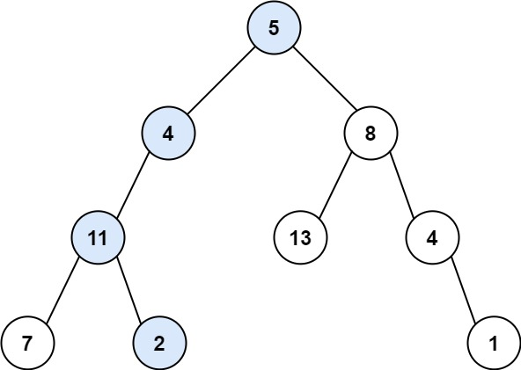

**Input:** root = [5,4,8,11,null,13,4,7,2,null,null,null,1], targetSum = 22

**Output:** true

**Explanation:** The root-to-leaf path with the target sum is shown.

**Example 2:**

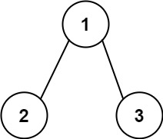

**Input:** root = [1,2,3], targetSum = 5

**Output:** false

**Explanation:** There two root-to-leaf paths in the tree:

(1 --> 2): The sum is 3.

(1 --> 3): The sum is 4.

There is no root-to-leaf path with sum = 5.

**Example 3:**

**Input:** root = [], targetSum = 0

**Output:** false

**Explanation:** Since the tree is empty, there are no root-to-leaf paths.

**Constraints:**

* The number of nodes in the tree is in the range [0, 5000].
* -1000 <= Node.val <= 1000
* -1000 <= targetSum <= 1000

/**

* Definition for a binary tree node.

* public class TreeNode {

* public int val;

* public TreeNode left;

* public TreeNode right;

* public TreeNode(int val=0, TreeNode left=null, TreeNode right=null) {

* this.val = val;

* this.left = left;

* this.right = right;

* }

* }

*/

public class Solution {

int sumVal = 0;

public bool HasPathSum(TreeNode root, int targetSum)

{

sumVal = targetSum;

return Traverse(root, 0);

}

bool Traverse(TreeNode root, int sum)

{

if(root == null)

{

return false;

}

sum += root.val;

if(sum == sumVal && (root.left == null && root.right == null))

{

return true;

}

else

{

return (Traverse(root.left, sum) || Traverse(root.right, sum));

}

}

}